[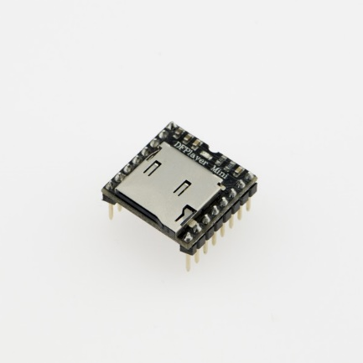](https://www.dfrobot.com/product-1121.html)**Introduction**

The **[DFPlayer Mini MP3 Player For Arduino](https://www.dfrobot.com/product-1121.html)** is a small and low cost MP3 module with an simplified output directly to the speaker. The module can be used as a stand alone module with attached battery, speaker and push buttons or used in combination with microcontrollers such as [Arduino](https://www.dfrobot.com/topic-277.html), [ESP32](https://www.dfrobot.com/topic-302.html), [Raspberry Pi](https://www.dfrobot.com/topic-272.html) and any microcontrollers with Uart.

**Specification**

* Sampling rates (kHz): 8/11.025/12/16/22.05/24/32/44.1/48
* 24 -bit DAC output, support for dynamic range 90dB , SNR support 85dB
* Fully supports FAT16 , FAT32 file system, maximum support 32G of the TF card, support 32G of U disk, 64M bytes NORFLASH
* A variety of control modes, I/O control mode, serial mode, [AD button](https://www.dfrobot.com/product-2267.html) control mode
* advertising sound waiting function, the music can be suspended. when advertising is over in the music continue to play
* audio data sorted by folder, supports up to 100 folders, every folder can hold up to 255 songs
* 30 level adjustable volume, 6 -level EQ adjustable
* (from DF Player Mini Manual.pdf) Built-in 3W amplifier

**Application**

* Car navigation voice broadcast;
* Road transport inspectors, toll stations voice prompts;
* Railway station, bus safety inspection voice prompts;
* Electricity, communications, financial business hall voice prompts;
* Vehicle into and out of the channel verify that the voice prompts;
* The public security border control channel voice prompts;
* Multi-channel voice alarm or equipment operating guide voice;
* The electric tourist car safe driving voice notices;
* Electromechanical equipment failure alarm;
* Fire alarm voice prompts;
* The automatic broadcast equipment, regular broadcast.

**Pin Map**

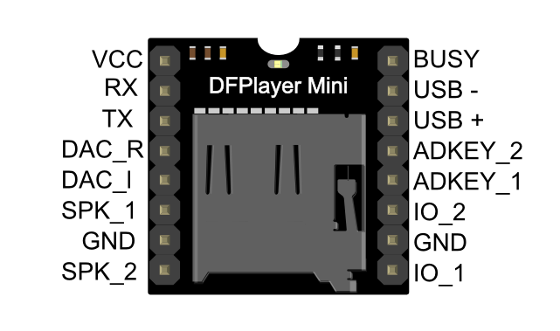

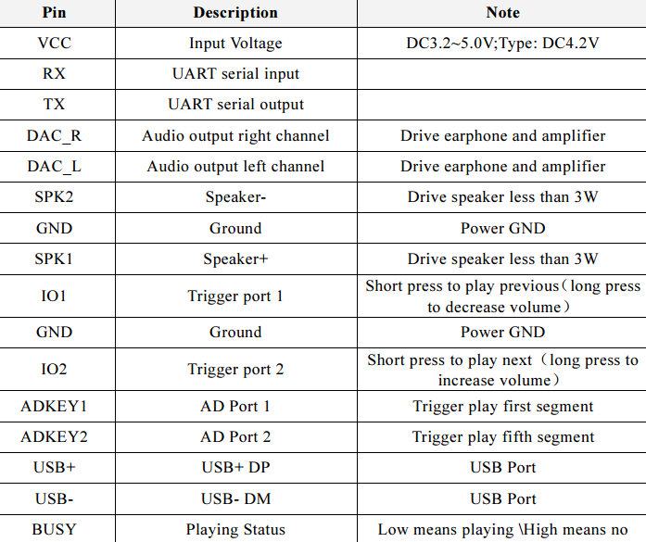

## Connection Diagram

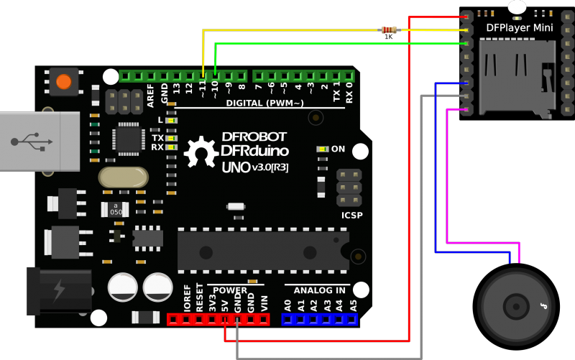

Note: The operating voltage of DFPlayer mini is 3.3 V, while most of the Arduino's operating voltage is 5 V. After our test, although it is possible to play music normally by directly connecting the Arduino directly to DFPlayer mini, there may be abnormal noises appearing. We recommend you to connect a 1k resistor in series with the RX pin of DFPlayer for voltage divider.